|  |
| --- |
| **LockedMe.com**  **(Application Screenshots)** |

**Version History:**

|  |  |
| --- | --- |
| Author | Nikhil Jain |
| Purpose | Screenshots of the application |
| Date | 10th August 2021 |
| Version | 1.0 |

Table of Contents

1. Welcome Screen 3

2. Current file names in ascending order 4

3. Add file in the existing directory 5

4. Delete a user specified file from the existing directory list 6

5. Search a user specified file from the main directory 7

6. Option to close the application 8

# Welcome Screen

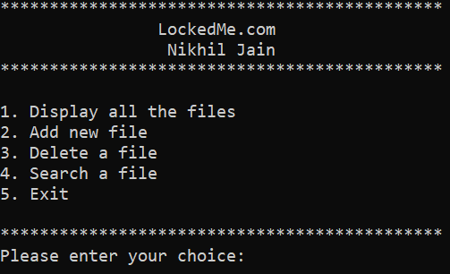

# Current file names in ascending order

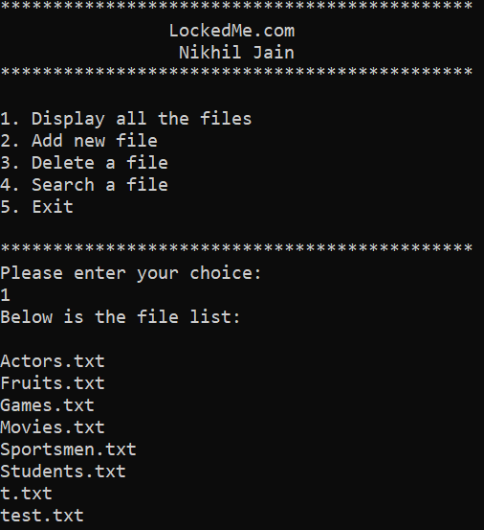

# Add file in the existing directory

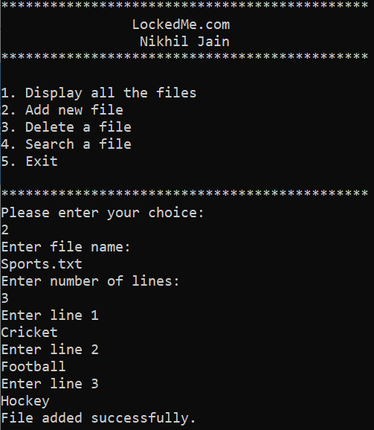

# Delete a user specified file from the existing directory list

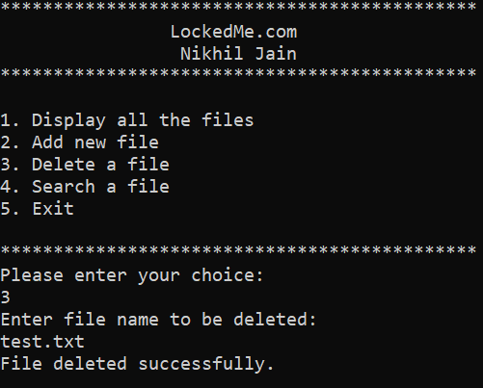

# Search a user specified file from the main directory

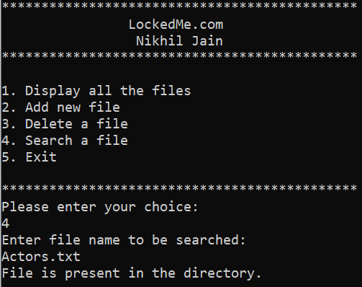

# Option to close the application

